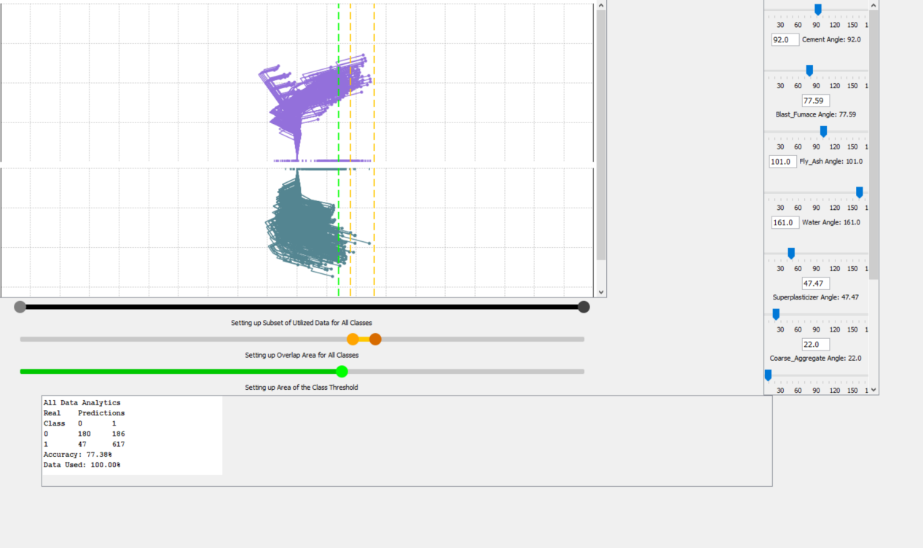

This dataset has 1030 entries, 3 classes and 9 dimensions and 8 quantitative input variables. Each variables represent a component in the mixture of the Concrete Compressive Strength. The measurement is in kg in a m^3 mixture. With the DV program, it’s easy to separate the classes by adjusting angles compared to the viscancas where we had to move things around.